# PeopleSafe - Twins Rx Adjudication (Multiple Births)

Process

Related Documents

**Description:** Procedures for processing twin’s Rx adjudication.

|  |
| --- |
| Process |

Access the Eligibility screen to determine if there are alternate IDs already assigned to the twins before making the request. If there is a self-generated, individual SSN (Social Security Number) or certificate number then the twins have alternate ID numbers established.

Accessing the Claims Processing information:

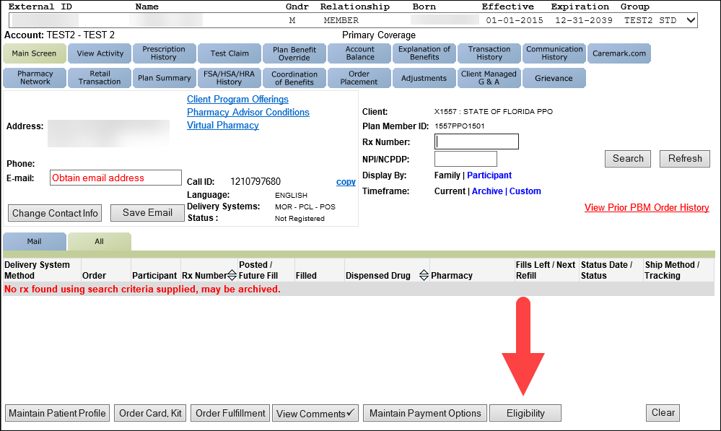

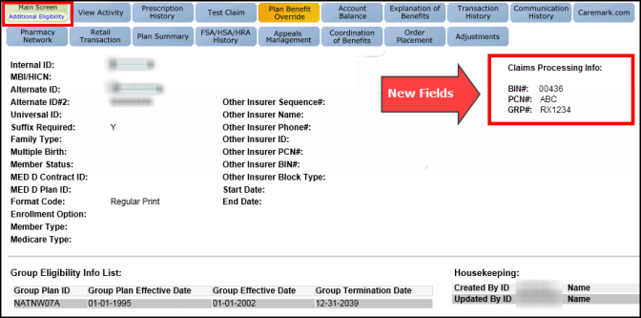

Perform the steps below:

|  |  |  |
| --- | --- | --- |
| **Step** | **Action** | |
| **1** | Review the Plan Benefit Overrides in the CIF on theSource to determine if an override is allowed for the rejected claim, (the override type would be Multiple Births): | |
| **If the CIF states…** | **Then….** |
| AM (Account Manager) Contact Client | Procedural Transfer to Senior Team. Refer to [When to Transfer Calls to the Senior Team](https://thesource.cvshealth.com/nuxeo/thesource/#!/view?docid=9eef064d-c7d7-42f7-9026-1497496b4d51) (016311). |
| Yes, and there is a reject in the system | Refer to [When to Transfer Calls to the Senior Team](https://thesource.cvshealth.com/nuxeo/thesource/#!/view?docid=9eef064d-c7d7-42f7-9026-1497496b4d51) (016311). |
| No | Advise the member the following:  I will submit a request to have the twins’ ID’s input into the system. This will occur within 5 business days. If you need to obtain the prescription immediately, you will need to pay for the Rx out of pocket and subsequently be reimbursed by the pharmacy after the change takes effect by having the retail pharmacy reprocess the prescription.  Proceed to the next step. |
| **2** | Setup permanent ID by creating Eligibility task.   * Task Category: **Eligibility** * Task Type: **Ineligible Participant /Spouse/ Dependent** * Queue: **Eligibility – San Antonio**   **Note:** One task is created for twins with the same DOB under the member’s name. Only create a callback task when the member specifically asks for a callback. In this scenario, you must indicate in the callback task notes that the member requested the callback.  **Turnaround:** Up to 5 business days | |
| **3** | Complete the Notes as follows: Include the Alternate ID followed by suffix code “01” or “02” for each twin. Specify which twin receives each ID number.   * If there is no alternate ID, then use the external ID followed by the suffix code of “01” or “02” for each twin. * If using the alternate or external ID number, include the full ID number on your task.   Refer to [Resolution Manager (RM) Task Types and Uses (029980)](https://thesource.cvshealth.com/nuxeo/thesource/#!/view?docid=3438a8ea-9ad1-4c4b-b710-57dab144493c) | |

Top of the Document

|  |
| --- |
| Related Documents |

[Customer Care Abbreviations, Definitions, and Terms](https://thesource.cvshealth.com/nuxeo/thesource/#!/view?docid=c1f1028b-e42c-4b4f-a4cf-cc0b42c91606) Index (017428)

[Compass and PeopleSafe - General Resolution Times/Turn Around Times (TAT) and Related Documents](https://thesource.cvshealth.com/nuxeo/thesource/#!/view?docid=863acba1-4370-4da9-9f6b-4cadf8633fbf) (028775)

**Parent Document:** [CALL-0049 Customer Care Internal and External Call Handling](https://policy.corp.cvscaremark.com/pnp/faces/DocRenderer?documentId=CALL-0049)

Top of the Document

Not to Be Reproduced or Disclosed to Others without Prior Written Approval

**ELECTRONIC DATA = OFFICIAL VERSION/PAPER COPY = INFORMATIONAL ONLY**